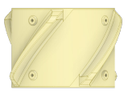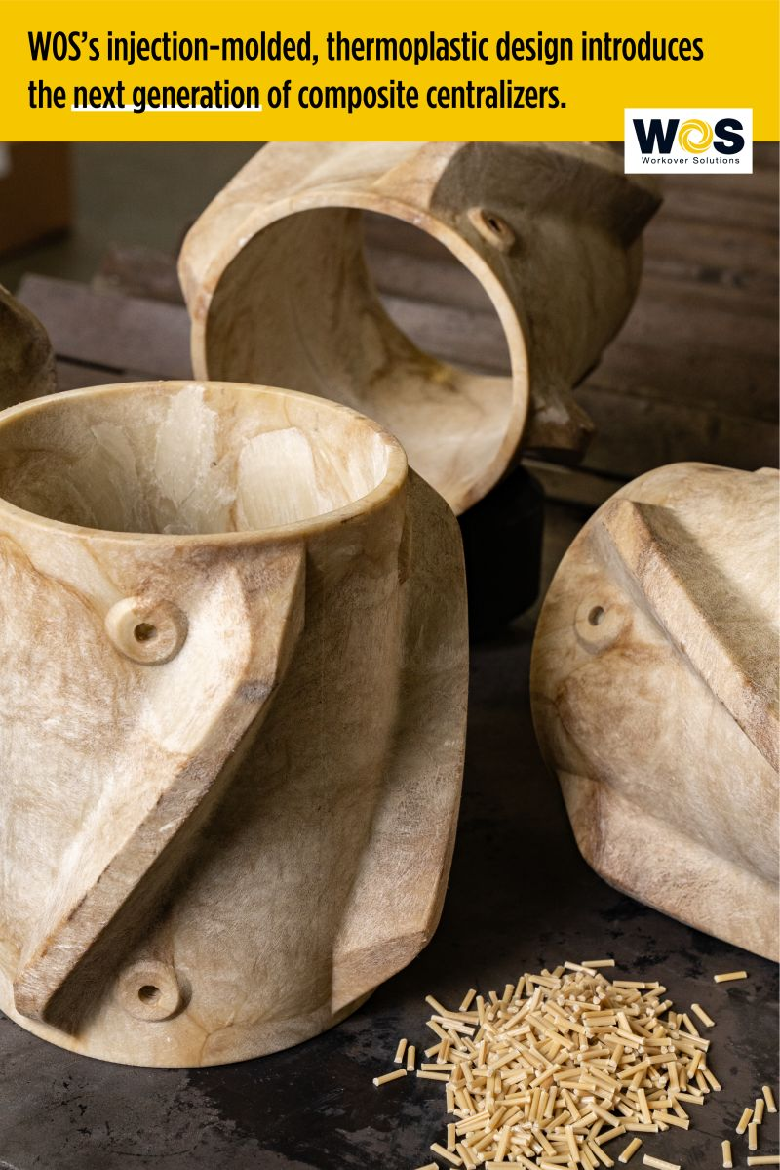

August 2023

**Product Details**

Size, in 9-5/8

Type Standard

Material Composite

Casing OD, in 9-5/8

Min Hole ID, in 12-1/8

Centralizer ID, in 9-7/8

Centralizer OD, in 12

Length, in 8

Weight, lbs 5.7

Set Screw Inserts No

A Pennsylvania oil and gas operator recently chose Workover Solutions to provide casing components for their casing running operations. The WOS casing **CentralizR** has an injection-molded, thermoplastic design that reduces costs and time over traditional steel centralizers in this application. On a recent pad, the operator utilized WOS’s **CentralizR** design for a trial. They gained a significant cost and time savings, simpler make-up operations, and simpler handling due to the compact design of the WOS **CentralizR**. Since the trial, the operator agreed to continue using the WOS **CentralizR** on future casing running operations

**WOS Casing CentralizRTM**

CentralizRTM Achieves Significant Cost Savings and Efficiency Gains for a Pennsylvania Operator

**Experienced People, Exceptional Tools**

www.workoversolutions.com

sales@workoversolutions.com

* Highly Durable injection-molded thermoplastic material
* Dynamic Blade Design
* Ease of Use in handling and installation
* Low Coefficient of Friction

**Casing Centralizer Solutions**

* High Costs for Traditional Steel Centralizers
* High Weights Due to Coefficients of Friction on Deeper Wells
* Limited Rig Floor Space



**Application Challenges**